Technical Report – TR30 Draft 0.7 23 Oct 2003


Met Office Observations Development (OD)

Microwave Radiometer Comparison at Cardington, Spring 2003

Draft Version
23 October 2003

Tim Hewison

Met Office Tel: +44 (0)118 378 7830
University of Reading, Meteorology Building Fax: +44 (0)118 378 8791
PO Box 243, Earley Gate, Reading E-mail: tim.hewison@metoffice.com
RG6 6BB, UK

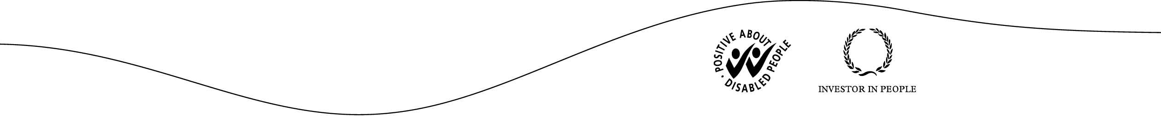

Introduction
During the spring of 2003, three microwave radiometers were operated at Cardington to study the evolution of boundary layer cloud. During the trial, 60 RS80H radiosondes were also launched from Cardington, including 5 intensive observation periods, when 5 or more sondes were released. In these cases, the soundings were often terminated after the boundary layer, as only one receiver was available.

Table 1 - Microwave Radiometers deployed in Cardington Trial, Spring 2003

Manufacturer  Model | Radiometrics WVR1100 | Radiometrics  MP3000 | Kipp & Zonen  MTP5
Channels | 2 channels:  23.8 GHz and  31.4 GHz | 12 channels:  22-30 GHz and  51-59 GHz | 1 channel:  59.6 GHz
Viewing angle | Zenith | Zenith | Elevation scanning
Observation Cycle | 8.5 s | 200 s | 300 s
Retrieves | Liquid Water Path  Integrated water vapor | Temperature profiles  Humidity profiles  Liquid water profiles  Liquid Water Path  Integrated water vapor | Temperature profile  0-1 km

This experiment provides a valuable dataset to allow the comparison of the data from these radiometers and radiosondes, which has been used to address the following issues:

- Are the radiometer calibrations consistent?
- How good are the retrievals of Liquid Water Path (LWP)?
- How good are the retrieved temperature profiles from the radiometers?
- Are the profiling radiometers able to retrieve temperature structure in the boundary layer?
– In particular, inversions.
- How variable is the atmosphere (in particular, cloud) on short time scales?
– And how frequently should we observe it with an operational instrument?

This report addresses these issues. The sister report [Price, 2003] also discusses the LWP retrievals, particularly from the WVR1100.

Case Studies
The following figures show some results of intensive observation periods during the Cardington trial of spring 2003. Temperature profiles measured by radiosondes at 1-3 hour intervals are plotted from 0-1000 m above ground level and compared with the profiles retrieved by radiometers supplied by 2 manufacturers.

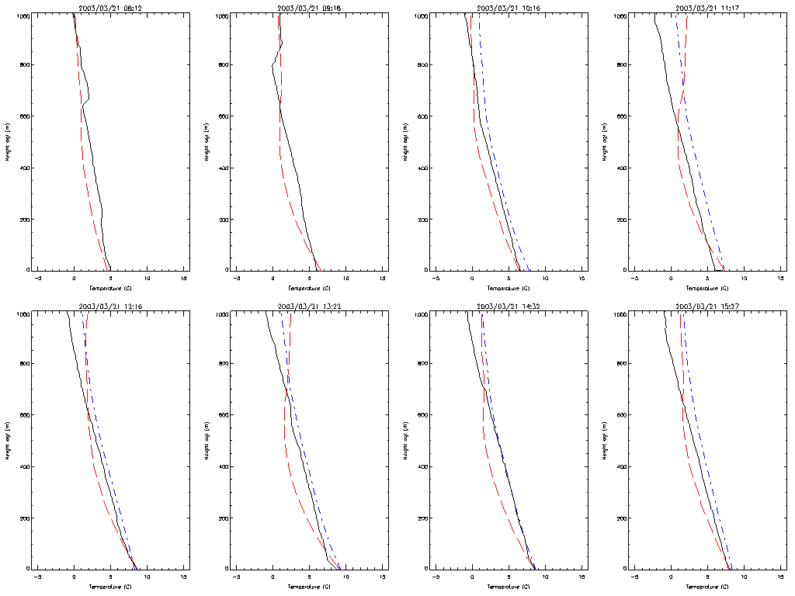
Figure 1 - Stratocumulus break-up Case Study at Cardington 21/3/03
Black=Radiosonde Red=MTP5 Blue=MP3000
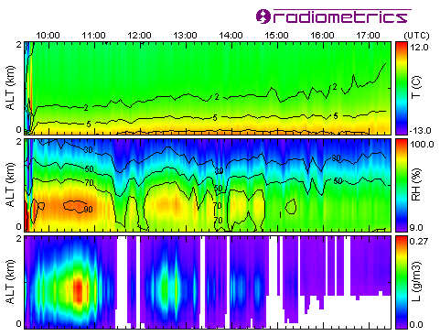
03/21/2003 08:12 8/8 Sc
03/21/2003 09:18 8/8 Sc
03/21/2003 10:16 8/8 Sc
03/21/2003 11:17 8/8 Sc
03/21/2003 12:16 8/8 Sc
03/21/2003 13:22 7/8 Sc
03/21/2003 14:32 7/8 Sc
03/21/2003 15:27 5-6/8 Sc

A layer of Stratocumulus broke up towards the end of this case study. However, the radiosondes showed only a weak inversion at ~600 m at the start of the day, which soon lifted to above 1000 m.

The MTP5 incorrectly retrieved an inversion or isothermal layer above ~600 m for most of this period.

The MP3000 correctly retrieved an adiabatic profile, although this does not indicate any great skill. The MP3000 retrievals were biased for the first 2 hours after it was turned on at 09:30.

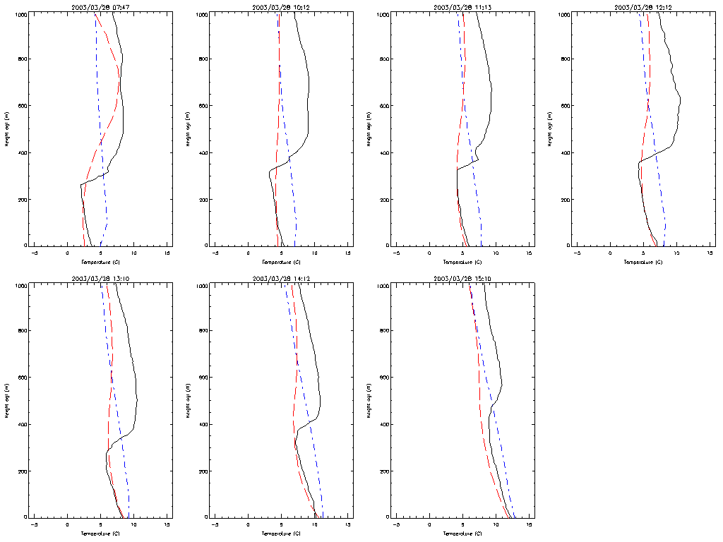
Figure 2 - Fog dissipation Case Study at Cardington 28/3/03
Black=Radiosonde Red=MTP5 Blue=MP3000
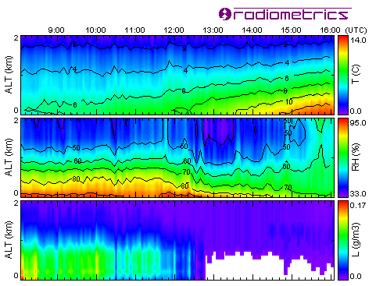
03/28/2003 07:47 8/8 St fog
03/28/2003 10:12 8/8 St fog
03/28/2003 11:13 8/8 St
03/28/2003 12:12 8/8 St
03/28/2003 13:10 2/8 St hazy Ci
03/28/2003 14:12 hazy Ci
03/28/2003 15:10 hazy Ci

A strong inversion capped a layer of radiation fog initially at ~250 m. With solar heating, the temperature of the fog layer increased until the fog lifted at ~12:00.

Initially, the MTP5 retrievals start with an isothermal layer, which is well represented, and consistently show an elevated inversion, which becomes weaker during the day. However, the temperature retrieved above 600 m is erratic, due to the poor sensitivity of this radiometer at higher altitudes.

Initially, the MP3000 incorrectly retrieves an isothermal layer based at the surface. Later in the day, its retrievals become more adiabatic, but fail to retrieve the elevated inversion.

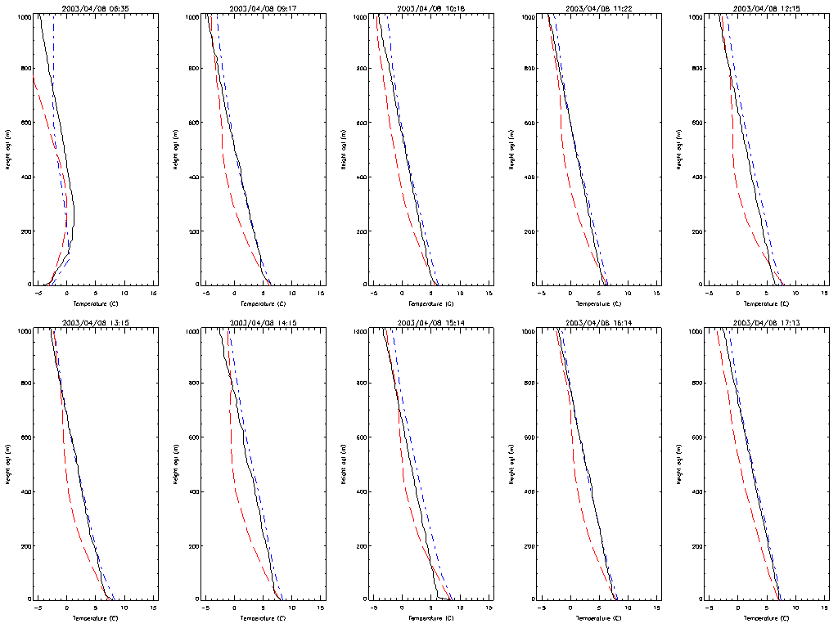
Figure 3 - Cumulus Formation Case Study at Cardington 8/4/03
Black=Radiosonde Red=MTP5 Blue=MP3000
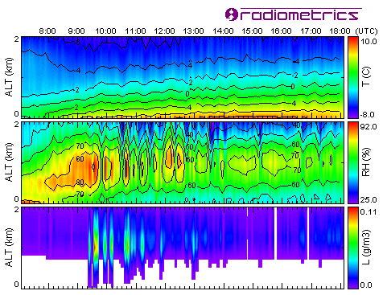
04/08/2003 06:35 Clear skies
04/08/2003 09:17 2/8 Cu
04/08/2003 10:18 6/8 Cu 4000ft
04/08/2003 11:22 5/8 Cu 5000ft
04/08/2003 12:15 3/8 Cu 5000ft
04/08/2003 13:15 3/8 Cu 5000ft
04/08/2003 14:15 2/8 Cu 5000ft
04/08/2003 15:14 1/8 Cu 5000ft
04/08/2003 16:14 2/8 Cu 5500ft
04/08/2003 17:13 1/8 Cu 5500ft

This day started with a strong surface inversion, which was well retrieved by both radiometers. Solar heating warmed the surface, resulting in a clearly adiabatic profile (below 1000 m) for most of the day, with a very shallow super-adiabatic layer at the surface during the early afternoon.

The MTP5 retrievals started well, correctly identifying the surface inversion. However, it produced profiles that were consistently super-adiabatic in the lowest 400 m, which is unphysical, and does not agree with the radiosondes. This could be addressed by adding a constraint in the retrieval to prevent this, but may indicate a systematic bias in the radiometer. At higher levels, its temperature retrievals were erratic, as usual.

The MP3000 also retrieved the initial strong surface inversion well. It then correctly retrieved adiabatic profiles for the remainder of the day. However, it was fooled by the super-adiabatic layer at the surface, and incorrectly forced the retrieved temperature to match its surface measurement.
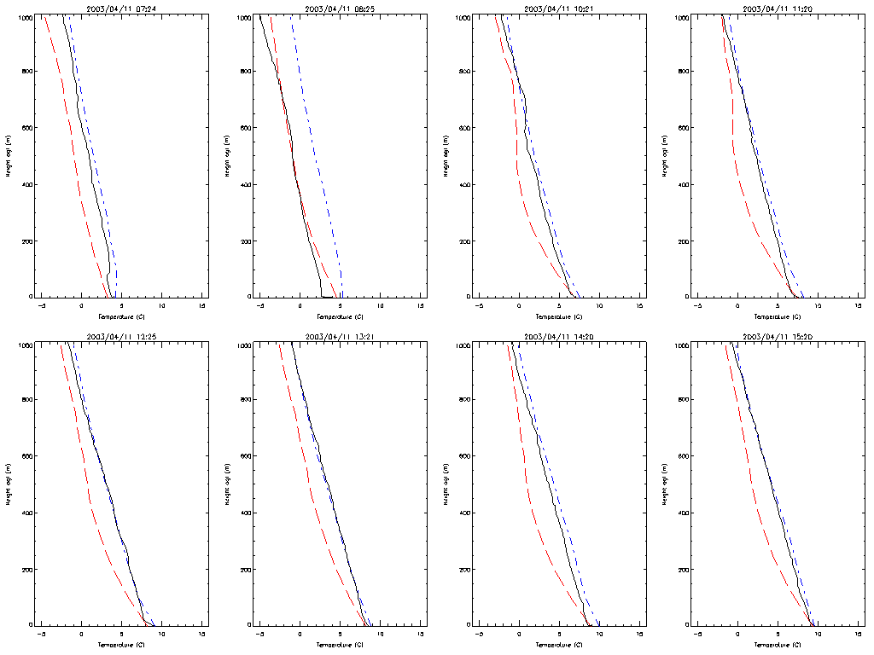
Figure 4 - Stratocumulus Evolution Case Study at Cardington 11/4/03
Black=Radiosonde Red=MTP5 Blue=MP3000
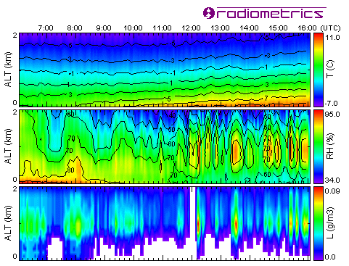
04/11/2003 07:24 7/8 Sc
04/11/2003 08:25 6/8 Sc
04/11/2003 10:21 7/8 CuSc
04/11/2003 11:20 7/8 CuSc
04/11/2003 12:25 ~5/8 CuSc
04/11/2003 13:21 7/8 Sc
04/11/2003 14:20 6/8 Sc
04/11/2003 15:20 7/8 Sc

The case study started with a weak lapse rate, which slowly strengthened to approach the dry adiabatic lapse rate, as solar heating warmed the surface through dense stratocumulus. The resulting convection produced Cumulus embedded in the Sc. There were no significant inversions below 1000 m.

The MTP5 again showed a tendency to overestimate the lapse rate in the lowest 400 m.

The MP3000 reproduced the radiosonde temperature profiles well, but again was fooled by the super-adiabatic layer at 08:25.

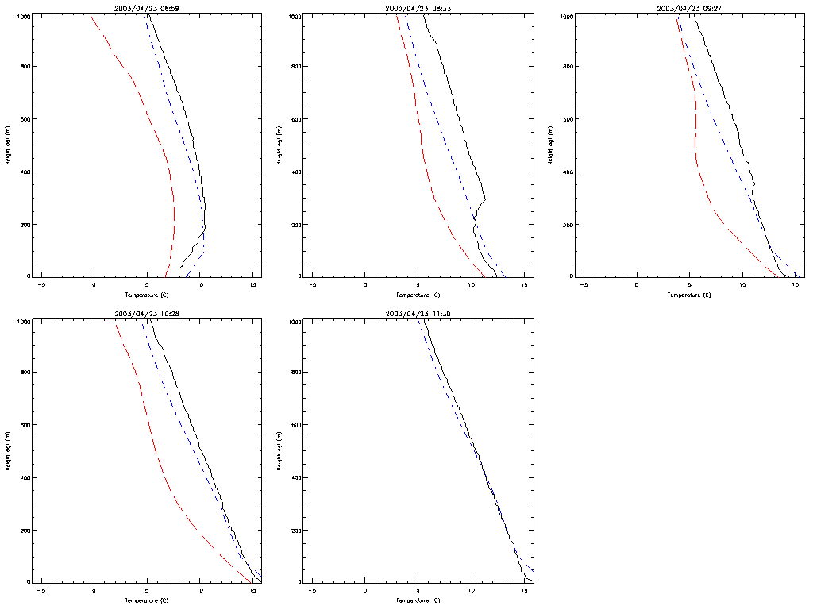
Figure 5 - Sc break-up and Cumulus formation Case Study at Cardington 23/4/03
Black=Radiosonde Red=MTP5 Blue=MP3000
04/23/2003 06:59 7/8 Sc 7000ft
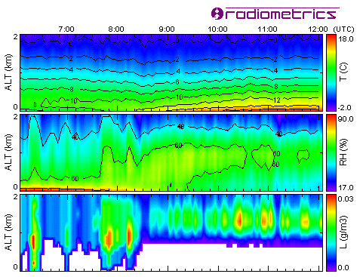
04/23/2003 08:33 2/8 Sc clearing
04/23/2003 09:27 Nil low cloud, 3/8 Cs
04/23/2003 10:28 1/8 Cu 6000ft + 5/8 Cs
04/23/2003 11:30 2/8 Cu 6000ft + 5/8 Cs

A surface inversion lifts and is eroded by solar heating of the surface during the morning. By 10:28 the profile follows the dry adiabatic lapse rate with a shallow super-adiabatic layer at the surface. The resulting convection produces a few small cumulus above 1000 m.

The MTP5 correctly retrieves the surface inversion at 06:59, although this feature is washed out by instrument's resolution. After this, it fails to retrieve the weaker inversion at 200 m at 08:33, and again retrieves an unphysically high lapse rate in the lowest 400 m. It also shows a consistent negative bias of 1-4°C throughout this day, suggesting an instrument calibration bias.

The MP3000 also retrieves the surface inversion at 06:59, apparently with a higher resolution than the MTP5 – although this may be an artefact of the neural network retrieval. Like the MTP5, it does not retrieve the weaker, elevated inversion at 08:33. Instead it retrieves an adiabatic profile, which closely matches that observed with the radiosondes later.

Statistics of retrieved temperature profiles at Cardington 0-1km
The temperature profiles retrieved by the algorithms supplied with the MP3000 and MTP5 radiometers were validated against simultaneous radiosonde observations. Only the data nearest to the time of launch of the balloon was used (usually within 2-3 minutes). The resulting statistics are summarised in Figure 6.
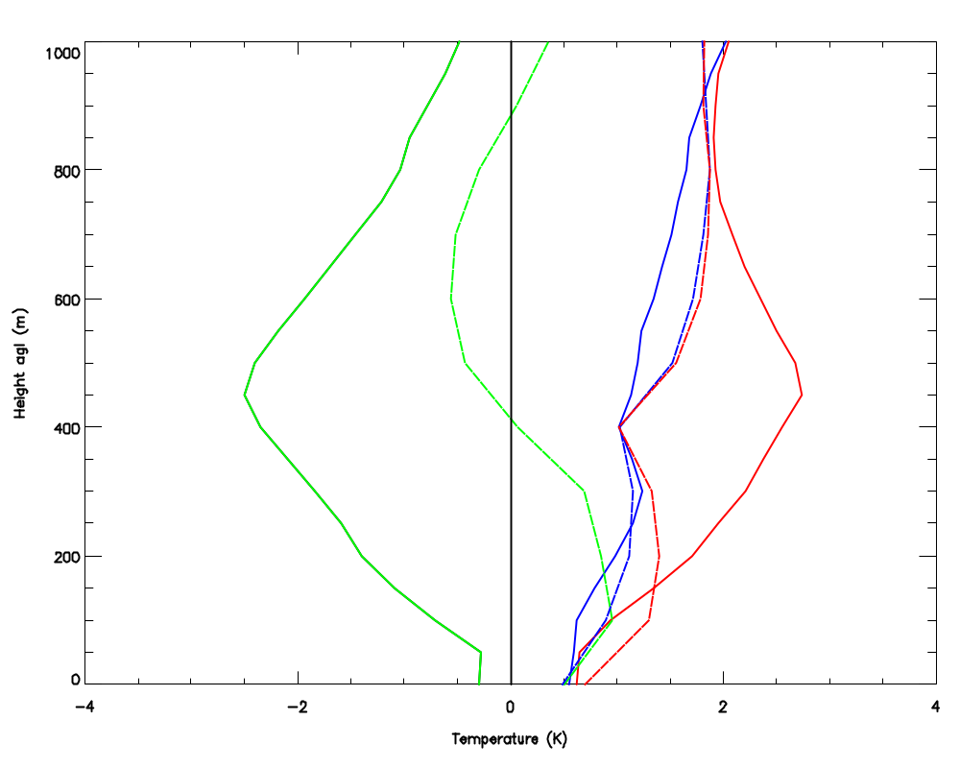
Figure 6 - Statistics of temperature profiles retrieved during Cardington Case Studies by MTP5 (solid lines) and MP3000 (dashed lines) with respect to Radiosondes
Green=Mean Bias Blue=Standard Deviation Red=r.m.s. Difference

This confirms MTP5 profiles have a large negative bias at ~400 m, which causes the retrieved profiles to have an unrealistically high lapse rate. This may be due to a calibration bias in the radiometer measurements, or a bias introduced by the retrieval algorithm. The MP3000 retrievals have a smaller, but still significant positive bias at 100-300 m.

Once these biases have been removed, the standard deviations of the retrievals from the radiometers are broadly similar, increasing from 0.5 K near the surface to ~2 K by 1000 m. This is larger than found in previous studies with the MP3000 (SD~1.5 K at 1 km) [Gaffard & Hewison, 2003]. This is probably due to the neural network being trained for a different climate, and greater diversity of the sample set, which extended outside the range of Camborne’s climatology.

The elevation scanning used by the MTP5 produced slightly less noisy retrievals than the MP3000, though this did not provide as large improvement in the lowest few hundred metres as predicted from theory [Cadeddu et al. 2002].
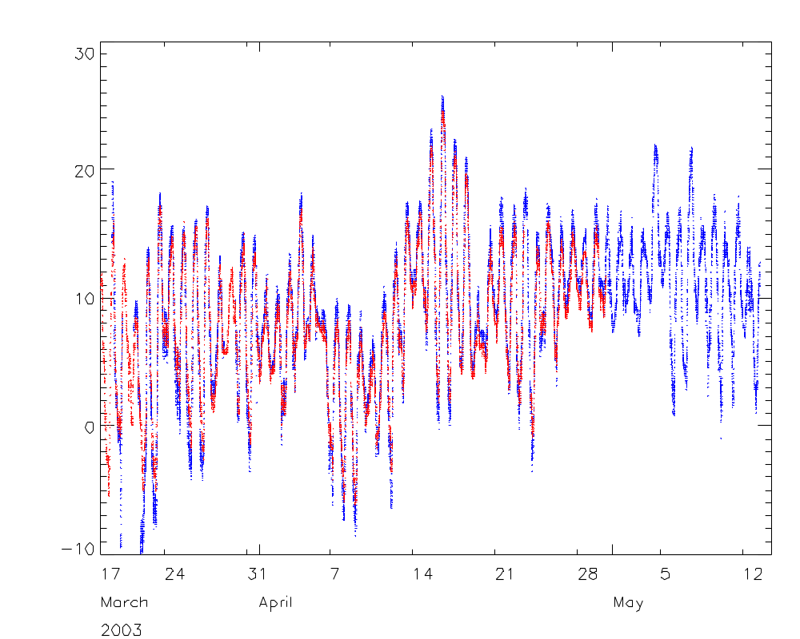
Figure 7 - Ambient Temperatures measured by MP3000 (blue)and MTP5 (red) radiometers during Cardington Trial

Figure 7 shows that the ambient temperature measured by the MTP5 had a smaller diurnal cycle than that measured by the MP3000. This could either be due to its elevated position of the roof of a hut, or poor ventilation or solar heating of the MP3000 sensor’s enclosure. However, Figure 6 shows that MTP5 has a lower the r.m.s. difference with respect to the radiosonde measurement at the ‘surface’, which is taken from a thermometer in a standard enclosure. This confirms the need to improve the ventilation of the enclosure used for the MP3000. A hardware modification has since been completed to address this problem. Its performance is under assessment.

Liquid Water Path (LWP) - Comparing MP3000 and WVR1100

The Radiometrics instruments observe zenith brightness temperatures, with 2 channels at similar frequencies: 23.8 GHz and 30.0/31.4 GHz for the MP3000/WVR110 respectively. Although these channels are calibrated in a similar way for both instruments, they operate on different observation cycles, and are supplied with different retrieval algorithms. These instruments and algorithms are compared in this section.

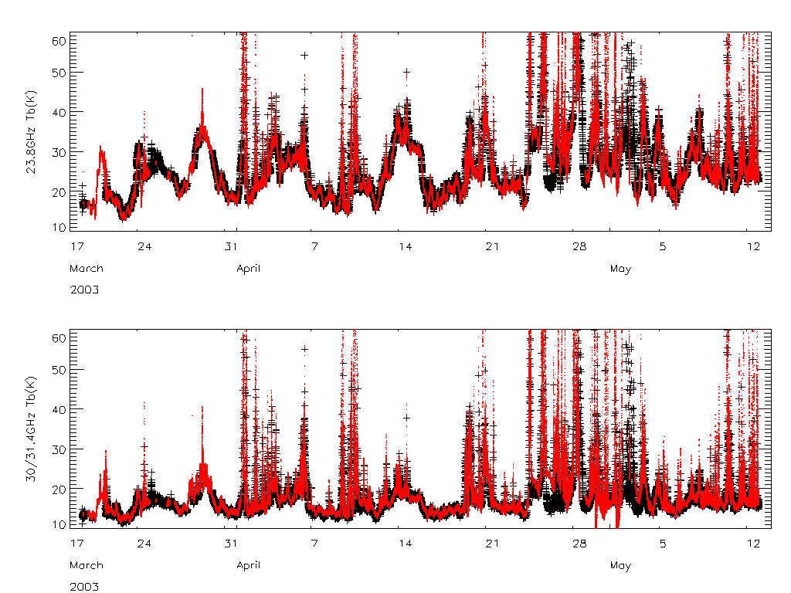
Figure 8 - Comparison of zenith brightness temperatures from MP3000 and WVR1100 radiometer during Cardington trial

Figure 8 shows the time series of brightness temperatures measured by the 23.8 GHz and 30.0/31.4 GHz channels of the WVR1100 and MP3000 during the Cardington trial. This shows that the instruments' cross-calibration is good, and that the brightness temperatures are very similar in clear conditions.

Radiometrics’ retrieval algorithms
Radiometrics supply algorithms to retrieve Liquid Water Path (LWP) and Integrated Water Vapour (IWV) from WVR1100 and MP3000 measurements. The retrievals for the WVR1100 are a bilinear regression, based on simulated brightness temperatures (actually opacities) from a training dataset of radiosondes. The MP3000 retrieval uses a neural network trained on simulated brightness temperatures from a dataset of Camborne radiosondes. This allows the retrievals to use information from other sensors, including infrared brightness temperature, intended to measure the cloud base temperature. This should improve the accuracy of LWP retrievals [Crewell and L➢hnert, 2003].

Figure 9 shows a time series of the Radiometrics retrievals of LWP and IWV during the Cardington trial. This shows the IWV retrievals are very consistent, but there are substantial differences in LWP retrievals, which are discussed below.

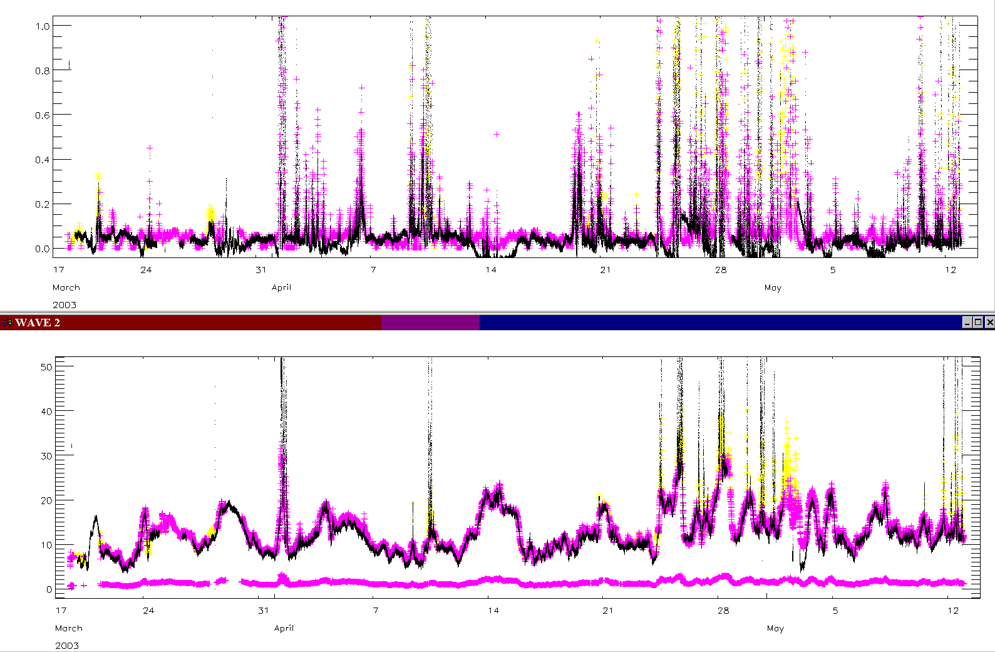
Figure 9 - Time series of Radiometrics’ retrievals from MP3000 and WVR1100 radiometers
Liquid Water Path (mm) in top panel,
and Integrated Water Vapour (mm) in bottom panel.

Jeremy Price’s retrieval algorithms
Jeremy Price [Price, 2003] developed an empirical bilinear regression to retrieve LWP from these data, which is not biased. The coefficients were derived by regressing observed opacity (derived from brightness temperature) against the adiabatic LWP calculated from coincident radiosonde profiles.

LWP = -0.0856-1.3522*tau23+3.9689*tau31

where tau23 and tau31 are the optical depths calculated from brightness temperatures observed at 23.8 GHz and 31.4 GHz respectively.

Jeremy’s algorithm can also be applied to the MP3000 measurements, replacing the 31.4 GHz channel of the WVR1100 with 30.0 GHz. In clear skies, the absorption at 30.0GHz is expected to be very similar to 31.4 GHz, and the observations are within the noise. In cloudy conditions, these retrievals are expected to overestimate the LWP due to the 9% decrease in cloud absorption between the frequencies 31.4 – 30.0 GHz.

LWP retrievals in clear skies
Radiometrics’ LWP retrievals in clear conditions from WVR1100 and MP3000 showed a positive bias during the Cardington experiment, shown in Figure 10. The data was first filtered to select periods with no low cloud using a simple threshold for the infrared brightness temperature: T_{ir} < 240 K.

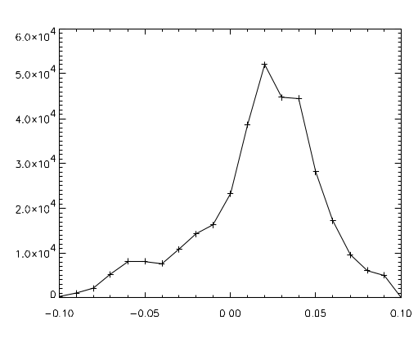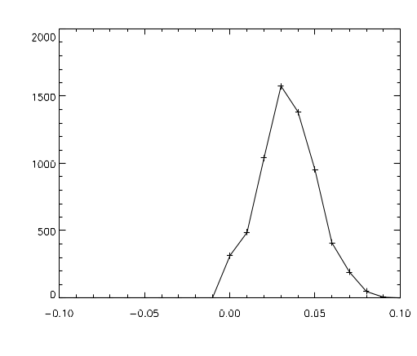
Figure 10 - Histogram of LWP (mm) during clear skies at Cardington
from WVR1100 (left) and MP3000 (right) using Radiometrics algorithms

Figure 11 shows the bias in clear sky LWP from Radiometrics’ algorithm for the WVR1100 varies with Integrated Water Vapour (IWV). This suggests the coefficients of the regression are not optimal. The Radiometrics’ LWP retrievals from the MP3000 have a positive bias that is independent of IWV. The cluster of points with a large bias around IWV=10 mm are due to interpolation errors, and should be ignored.
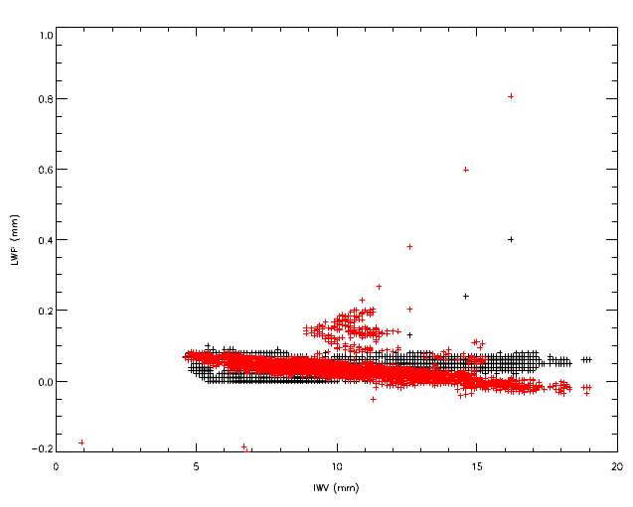
Figure 11 - Bias in LWP=0mm for MP3000 and WVR1100 depends on Humidity (IWV)

On the other hand, Jeremy Price’s bilinear regression retrieves is unbiased for LWP=0 mm for both radiometers, as shown in Figure 12. This confirms the bias found in the LWP retrieved by the Radiometrics algorithm is not due to the microwave radiometer measurements. Instead, it is likely to be an artefact of the neural net algorithm or a bias in one of the other inputs – for example the infrared radiometer. However, more recently the same bias was observed at Camborne, before the corroded lens on the IR radiometer was replaced. Before the lens deteriorated (March 2003) and since replacing the lens, the LWP bias in clear skies has disappeared, so it appears that this was a significant cause of bias in retrievals of low LWP.

Jeremy’s algorithm also produces unbiased estimates of clear sky LWP from MP3000 during the Camborne and Chilbolton trials, as it is independent of the IR brightness temperature.
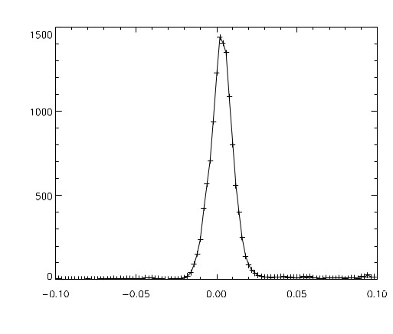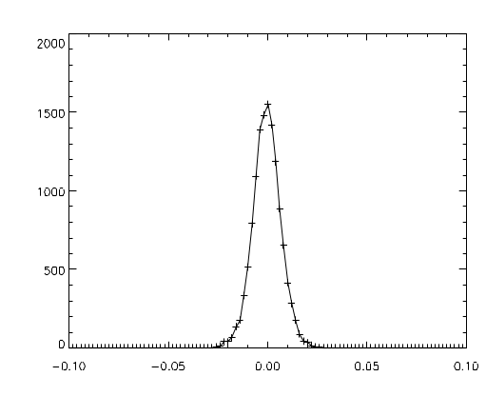
Figure 12 - Histogram of LWP (mm) during clear skies at Cardington
from WVR1100 (left) and MP3000 (right) using Jeremy Price’s bilinear regression

LWP retrievals in cloudy skies
Figure 9 shows a time series of the Radiometrics retrievals of LWP and IWV during the Cardington trial. This reveals the WVR1100 retrieves LWP<0 mm consistently for a few hours during periods of high IWV. It also shows that the Radiometrics LWP retrievals from both instruments follow very similar patterns, although the values retrieved from the MP3000 in cloudy conditions are ~40% higher than the WVR1100 retrievals.

When Jeremy Price’s algorithm is applied to the 23.8/30.0 GHz channels of the MP3000, this yields LWP values 12% lower than those retrieved from the same coefficients applied to the WVR1100. This was calculated as the median of the ratio between the two retrievals only in conditions independently assessed as having low cloud (IR Brightness Temperature T_{ir} > 270 K). This is approximately consistent with a 9% decrease in cloud absorption between the frequencies 30.0-31.4 GHz.

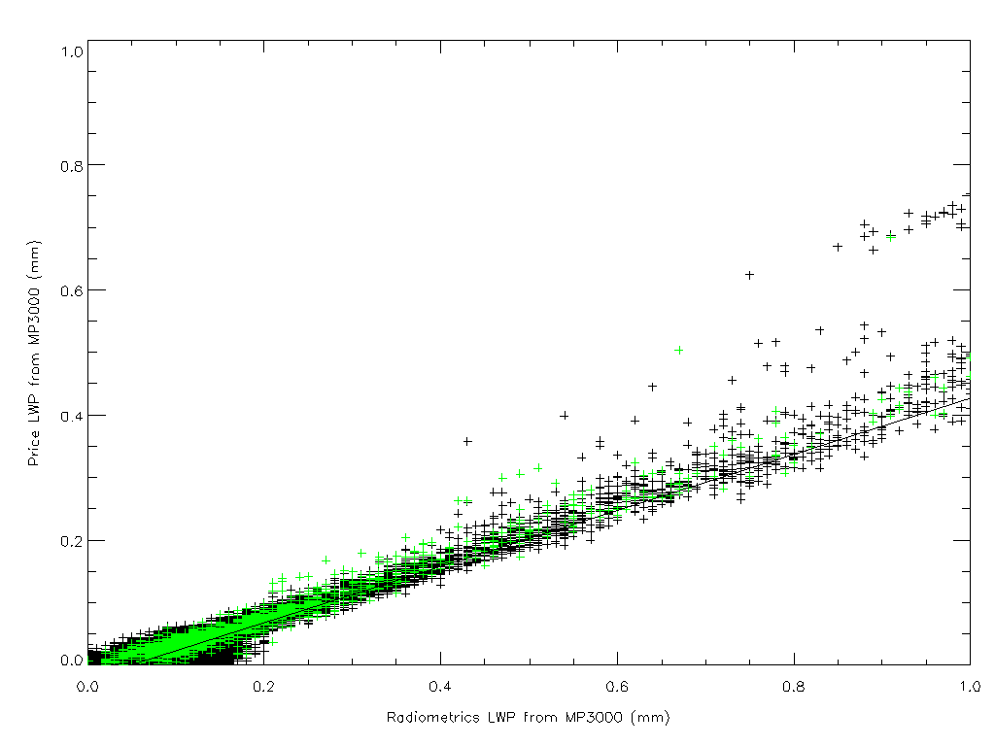
Figure 13 - Radiometrics LWP and Price LWP retrievals from MP3000 (Green=low cloud)

Radiometrics LWP retrievals from the MP3000 are found to be a factor of ~2 larger than the values retrieved using Jeremy Price’s bilinear regression on the same data. Yet this is based on the adiabatic liquid water content calculated from radiosonde profiles, which is theoretically the highest value obtainable. This difference is also observed in data from Camborne, and is found to be independent of contamination of the infrared radiometer’s lens, which produced a bias in LWP retrievals in clear conditions. This suggests there is a bias in Radiometrics’ neural network. Later in this report, only LWPs retrieved using Jeremy Price’s algorithm are analysed.

However, observations with dual frequency cloud radar at Chilbolton are consistent with Radiometrics’ neural network retrieval of LWP. This will be addressed more fully in a future report.

Atmospheric Variability
During the Cardington trial of spring 2003, the MP3000 radiometer was deployed to make co-located observations with their WVR1100 radiometer. One of the aims was to extend our estimates of the atmospheric variability to shorter time scales accessible using the higher sample rate obtained with the WVR1100.

This is important for specifying the rate at which different atmospheric parameters should be optimally sampled. This will depend on the noise level achievable for observations at different sample rates, as well as what is required for operational use. Although the optimal period could be different for temperature, humidity, cloud, in practice the observation strategy will be limited by the fastest varying parameter. Temperature is expected to vary most rapidly at the surface. As humidity and cloud retrievals have very limited vertical resolution, the integrated quantities only are analysed here. This also facilitates comparison with the 2 channel WVR1100 radiometer.

The temporal variability of any parameter, x, can be characterised by its Time Structure Function, D_{x}(τ), which is defined as:
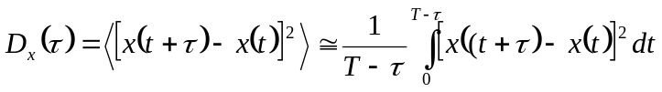 for τ ≤ T/2
where τ is the time lag under consideration. When using (1) the expectation value was replaced by computing the ensemble average value using all time epochs t in the dataset, where T is the considered time period. Restricting τ to T/2 will prevent inclusion of non-representative data from time lags near T, where very little data is available.

Within limited ranges of τ we can approximate the time structure function by the power-law:
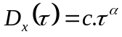

Structure functions are calculated for each parameter from data from the whole duration of MP3000 deployment was taken: 19/3-13/5/03. Data flagged as rain or very thick cloud (LWP>0.8 mm) was rejected as it was likely to be contaminated by water on the radiometers’ windows.

The structure functions were averaged bin-wise linearly. These are dominated by data where the atmosphere is most variable. When deriving an observation strategy, it is important we allow the representation of rapidly changing conditions.

Integrated Water Vapour

Treuhaft and Lanyi [1987] constructed a statistical model of water vapour fluctuations by approximating the spatial structure of refractivity fluctuations by Kolmogorov turbulence theory and assuming temporal fluctuations are caused by spatial patterns advected by wind. They expressed this model in terms of spatial and temporal structure functions of the Wet Delay experienced by VLBI, which is proportional to the Integrated Water Vapour amount. For time scales, τ << h / v, they found the structure functions, D ∝ τ^{5/3}, whilst on longer times, τ >> h / v, the structure functions, D ∝ τ^{2/3}, where h is the scale height of the wet troposphere. Treuhaft and Lanyi assumed h ~ 1km, whilst noting generally h ~ 2km and v ~ 8 m/s is the typical wind speed at height, h, giving the scale break at τ ~ 125 s. However this value is dependent of the climatology of the site in question, and could be estimated from a radiosonde database. They describe the two scales as being “consistent with the intuitive picture that many small irregularities contribute to the short distance structure, while a small number of larger irregularities dominate the long distance structure.” Their model is compared to the observed time structure function of Integrated Water Vapour in Figure 14.

The annual average water vapour scale height at Camborne is calculated to be 0.9 km, although it is generally higher is summer and lower in winter, proportional to the IWV. The mean wind speed at this height is 11.2 m/s at Camborne. The corresponding critical time scale is τ ~80 s.
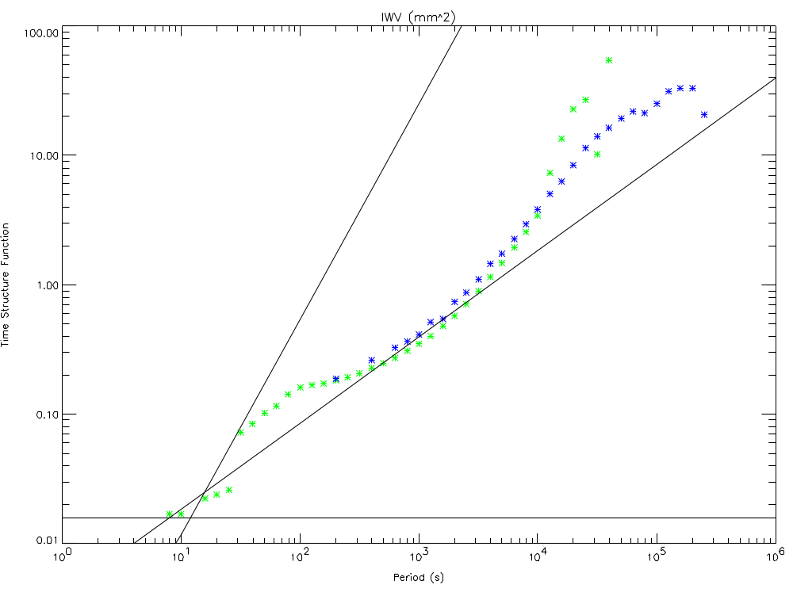
Figure 14 - Integrated Water Vapour (IWV) Time Structure Functions (kg.m⁻²) retrieved from
MP3000 (blue) and WVR1100 (green) during Cardington trial of Spring 2003.
Lines show theoretic slopes of 2/3 and 5/3, and 0 (instrument noise).
Figure 14 shows close agreement between the Time Structure Function of IWV retrieved from the MP3000 and WVR1100 on timescales of ~2 minutes to ~3 hours. The latter shows a clear diurnal cycle. The variability of IWV continues to decrease down to timescales of ~10 s, although the WVR1100 shows another increase in the region of ~100 s, which may correspond the timescales of small cumulus clouds advecting over the radiometer.

The horizontal line in Figure 14 indicates the white noise spectrum associated with instrument noise. This is equivalent to an r.m.s. uncertainty in the retrieved IWV of 0.09 kg/m², which is consistent with the expected performance of a simple bilinear regression retrieval, based on a radiometric noise, NEΔT=0.1 K. This is a factor of 15 times better than the analysis by Crewell & L➢hnert [2003] for neural network retrievals of IWV from 3 channel radiometer, with noise of 1 K including cloud base height and temperature. Structure in the IWV is evident above the instrument noise level on time scales longer than ~30 s. If the instrument noise were reduced, it would be possible to retrieve smaller fluctuations, which occur on shorter time scales.

The form of the structure function matches the theoretical predicted slopes of Treuhaft and Lanyi [1987]. However, this could be more realistically interpreted as humidity fluctuations being driven by diurnal cycles and convective eddies, causing local maxima in the structure functions on time scales of τ~43200 s and ~100s respectively.

Liquid Water Path

To analyse the variability of the Liquid Water Path (LWP), a common retrieval algorithm was applied to measurements from both radiometers. Jeremy Price’s bilinear regression was used. The Time Structure Functions were calculated from all the retrieved LWP values where rain or heavy cloud (LWP>0.7 kg.m⁻²) was not present. The results are shown in Figure 15.

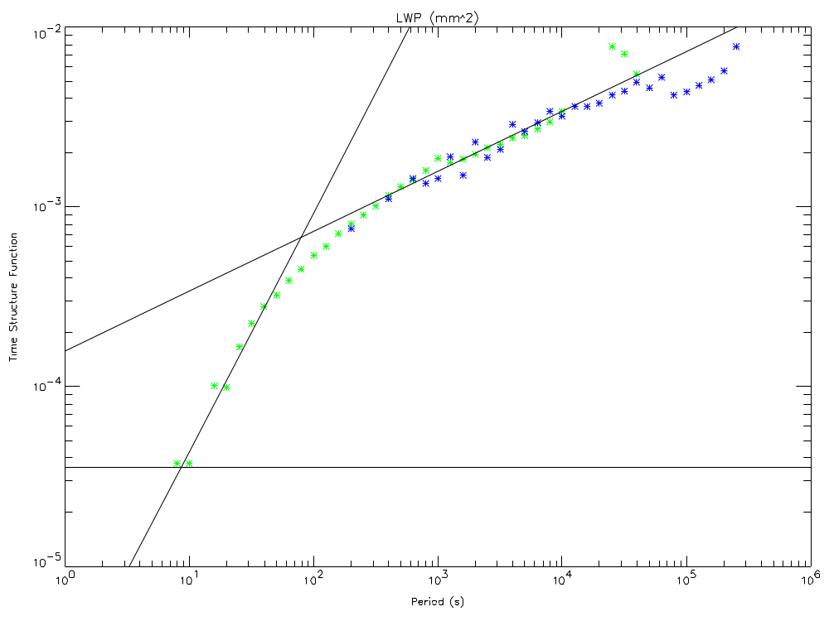
Figure 15 - Liquid Water Path (LWP) Time Structure Functions (kg.m⁻²) retrieved from
MP3000 (blue) and WVR1100 (green) during Cardington trial of Spring 2003.
Lines show theoretic slopes of 1/3 and 4/3, and 0 (instrument noise).
The Time structure function, D_{τ} shows a maximum corresponding to the diurnal cycle for τ ~4.10⁵ s and for τ >100 s, D_{τ} ∝ τ^{4/3}, while for τ <100 s, D_{τ} ∝ τ^{1/3}. The variability in LWP drops dramatically over periods shorter than ~100 s. This is consistent with the explanation that this is the typical timescale for cumulus clouds, responsible for the corresponding maximum in Figure 14 at this timescale. On time scales shorter than ~10 s, the spectrum becomes flat, as it is limited by the instrument noise.

The noise level of LWP is equivalent to an r.m.s. uncertainty of ~4 g/m². This is much lower than values quoted by Price [2003] and Fig.2 of Crewell and L➢hnert [2003], who suggest figures of 15 g/m² for a 2 channel radiometer retrieval with NEΔT = 0.1 K.

It is clear from Figure 14 and Figure 15 that the atmosphere should be sampled at τ <100 s to capture most variability in humidity and cloud. Sampling more rapidly will reveal structure on smaller scales up to the point where the instrument noise level is reached. This currently occurs at τ ~10 s for the WVR1100, but will depend on the instrument noise level, which can only be reduced by integrating for longer. This in turn limits the time scale of fluctuations that can be observed. This trade-off results in different optimum sample rates for different applications. To study cloud properties in detail, the WVR1100 is probably close to an optimum observation period of ~10 s. To retrieve humidity profiles with minimum noise, observations should be integrated to the point where the slope of the Time Structure Function is equal to ½. This corresponds to a period of ~60 s in these examples.

Zenith Brightness Temperatures
Time series of zenith brightness temperatures can be analysed in the same way. The resulting structure functions are shown in Figure 16 for the radiometers’ two common frequency bands.

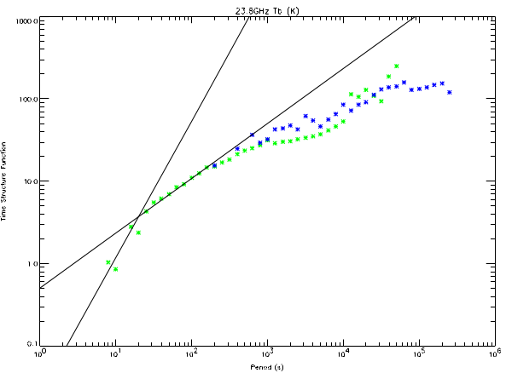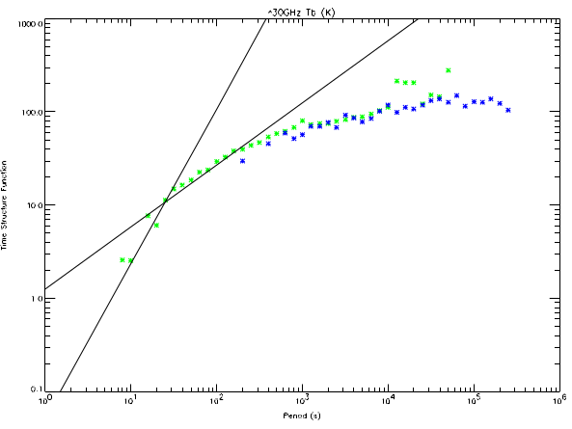
Figure 16 – Time Structure Functions of Zenith Brightness Temperatures (K²) at
23.8 GHz (left panel) and 30/31.4 GHz from MP3000 (blue) and WVR1100 (green).
Lines show theoretic slopes of 2/3 and 5/3, and 0 (instrument noise).
The Time Structure Functions for both channels are influenced by fluctuations in humidity and cloud to different extents, but follow similar patterns of slowly increasing variability on time scales τ > 100 s, with structure growing more rapidly on shorter time scales, but noise limited constant variability on short time scales (τ <10 s). The horizontal lines on both panels indicate the r.m.s. noise equivalent to a radiometric noise, NEΔT=0.2 K. The WVR1100 shows variability approaching that level only at the shortest time scales observed, τ~10 s.

These results suggest that, on average, sampling once per minute is optimal. However, this period may be extended in clear conditions, and additional cloud information would be available from sampling more rapidly in windy conditions, where clouds advect rapidly across the instrument’s field of view.

Conclusions

A bias found in the temperature profiles retrieved by the MTP5 suggests a calibration problem with this instrument, which may have impaired its performance on this trial. After removing this bias, the temperature profiles retrieved from MTP5 were statistically a little better than those from the MP3000 in the lowest 1km. This confirms there is some benefit in the use of elevation scanning, as suggested by a theoretical study [Cadeddu et al, 2002].

Shallow surface inversions and super-adiabatic layers are not well retrieved by the current regression-based retrievals, because too much weight is put on the surface sensors. This weight is derived statistically from a large sample of sondes, but in these cases, the shallow surface layer is decoupled from the rest of the boundary layer, making the surface sensors less representative. This must be addressed in future retrieval schemes.

Elevated inversions were generally poorly resolved by both microwave radiometers, due to their vertical resolution decreasing with height. This is a fundamental limitation of passive retrievals from the ground, but may be improved by exploiting information from active instruments in the retrieval.

The neural network retrieval of Liquid Water Path (LWP) supplied with the MP3000 radiometer produced a positive bias in clear skies during the Cardington trial. This was found to be introduced by a bias in the infrared radiometer, caused by deterioration of its lens. Both Radiometrics’ retrieval algorithms were found to overestimate the LWP compared to a bilinear regression using adiabatic liquid water calculations from radiosondes. The cause of these biases should be investigated, but it is unrelated to the infrared radiometer bias.

The variability of retrieved Integrated Water Vapour and LWP has been analysed using Time Structure Functions. The results show fluctuations occur on different scales, associated with convection and the diurnal cycle. To capture most atmospheric variability, operational radiometers should be designed to sample cloud parameters with a period of ~60 s.

References

M.P.Cadeddu, G.E.Peckham, C.Gaffard, 2002: The vertical resolution of a ground-based microwave radiometer analyzed through a multiresolution wavelet technique, IEEE Trans. on Geoscience and Remote Sensing, Vol.40 No.3, Mar 2002, pp. 531-540

S.Crewell and U.L➢hnert, 2003: Accuracy of cloud liquid water path from ground-based microwave radiometry: 2. Sensor accuracy and synergy, Radio Science, Vol.38, No.3,8041-8042, MAR 7, 2003.

C.Gaffard and T.J.Hewison, 2003: Radiometrics MP3000 Microwave Radiometer Trial Report, Met Office, Observations/Development, Technical Report TR26, Available from National Meteorological Library, UK.

T.J.Hewison and C.Gaffard, 2003: Radiometrics MP3000 Microwave Radiometer Performance Assessment, Met Office, Observations/Development, Technical Report TR29, Available from National Meteorological Library, UK.

Jeremy Price, 2003: Operation of a Radiometrics WVR-1100 passive microwave radiometer at the Met Office Research Unit, Cardington, Cardington Technical Note 61.

R.N.Treuhaft, G.E.Lanyi, 1987: The effect of the dynamic wet troposphere on radio interferometric measurements, Radio Science, 22 (2): pp.251-265.

