Performance assessment of Liquid Nitrogen Calibration Target supplied by Fred Solheim (Radiometrics) at 89, 157 and 183 GHz

Tim Hewison
And
Andrew McGrath

MRF Technical Note No. 39
Issue: 1
6 June 2001

(8 pages)

Controlled Copy Number: - N/A.

 | Name | Date | Signature
Document Prepared by | Tim Hewison | 7/2/02
Document Checked by | Jonathan Taylor | 7/2/02
Document Authorised by | Jonathan Taylor | 7/2/02

This document replaces all previous issues


Met Office Tel: +44 (0)1252-395781
Building Y70, Cody Technology Park Fax: +44 (0)1252-370789
Ively Road, Farnborough E-mail: tim.hewison@metoffice.com
Hampshire GU14 0LX, UK

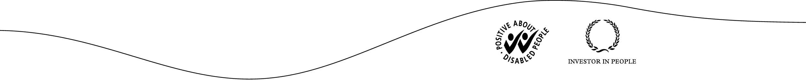

Introduction

Fred Solheim kindly donated a calibration target designed for use with Radiometrics ground-based radiometers operating at 24-60GHz for evaluation at higher frequencies. This was tested in the lab with MARSS on 18 May, 1 and 5 June 2001. This report discusses the observed and modelled performance of this target and recommends how it may be used to validate the calibration of MARSS observations.

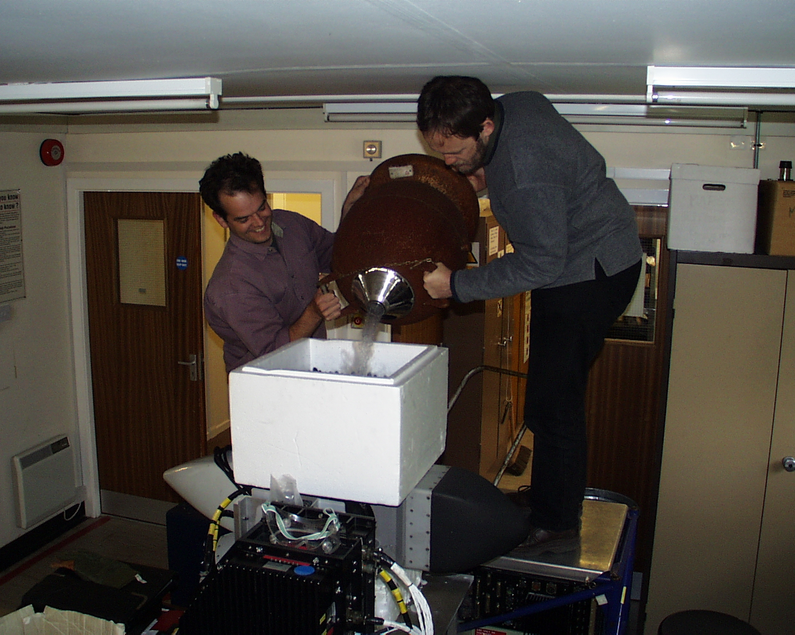

Thermal Performance of Target

On the first occasion, the target was tested in the lab it was placed on top of the MARSS pod and filled with ~20 litres of liquid nitrogen. It was expected that condensation would form on the outer surface of the target polystyrene, however none was observed for the full duration of the test (>1hr).

On the second occasion, the target was filled with 30 litres of liquid nitrogen. However, the uppermost parts of the absorber were still exposed. Initial brightness temperatures were consist with those observed on the first day, suggesting the depth of nitrogen was sufficient on both occasions. However, on the 1 May, the dew point was slightly higher (measured at +10°C), and condensation was seen to form on the sides of the target within minutes. This continued to accrue until large drops formed after several hours. However, the underside of the target remained dry until it was lifted from the MARSS pod for inspection and insertion of an additional slab of polystyrene to measure its insertion loss. It seems that the close contact with the MARSS pod was sufficient to slightly dry the air in this area. It is therefore assumed that condensation will form on this surface when the dewpoint is greater than about +8°C if the target were to be used in a outdoor environment with even the gentlest breeze.

On 5 June, the dewpoint in the lab was again lower (+8°C), and no condensation formed on the underside of the target, until it was lifted slightly from the MARSS pod at 14:06. Water vapour immediately began to condense from the air onto the surface. Although it was initial impossible to detect this by eye, it caused a rapid increase in brightness temperatures, shown below. As expected the higher frequency channels are more sensitive to extinction by the liquid water droplets. This emphasises the need to keep the lower surface of the target in a dry environment at all times.
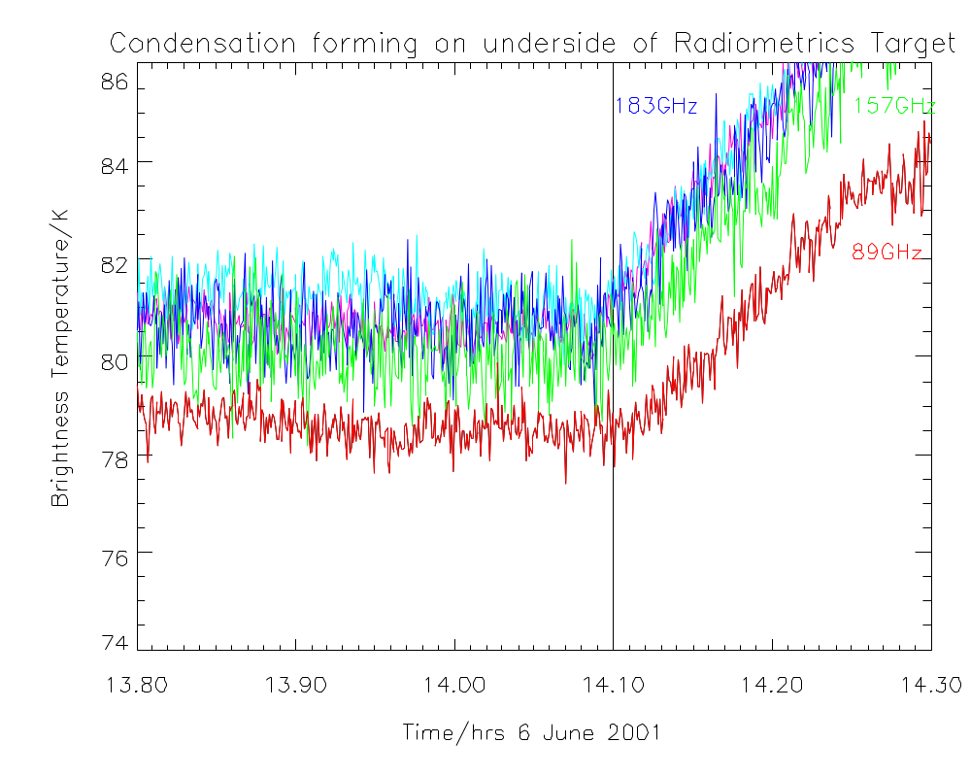
The depth of the liquid nitrogen was observed to drop to ~6cm during the 6 hours since filling (from 17cm initially) with the lid fitted for most of this period. This illustrates the target's excellent thermal insulation. Most of this loss occurred when the target was nearly full. As the level drops, the cold pool of gas forming above the liquid nitrogen forms an effective barrier to further loss.

Radiometric Stability of Target

On both occasions, the measured brightness temperature of the target was found to decrease by 1-1.5K during the first few minutes after filling, then remain constant for a period of ~30 minutes. It was initially suggested that this initial decrease is due to the cooling of the polystyrene base of the target from ambient initially, to an equilibrium of ~179K. The observed decrease would then corresponds to a fraction of the anticipated loss through the targets base. However, the decrease is approximately the same for each channel. Another explanation is that this decrease is due to a break-down of the planar interface between the cryogen and polystyrene due to it becoming somewhat porous. This would reduce the apparent brightness temperature by 1.4K in each channel, and is consistent with the observations. This theory could be tested by lining the polystyrene with an impermeable membrane before filling with cryogen.
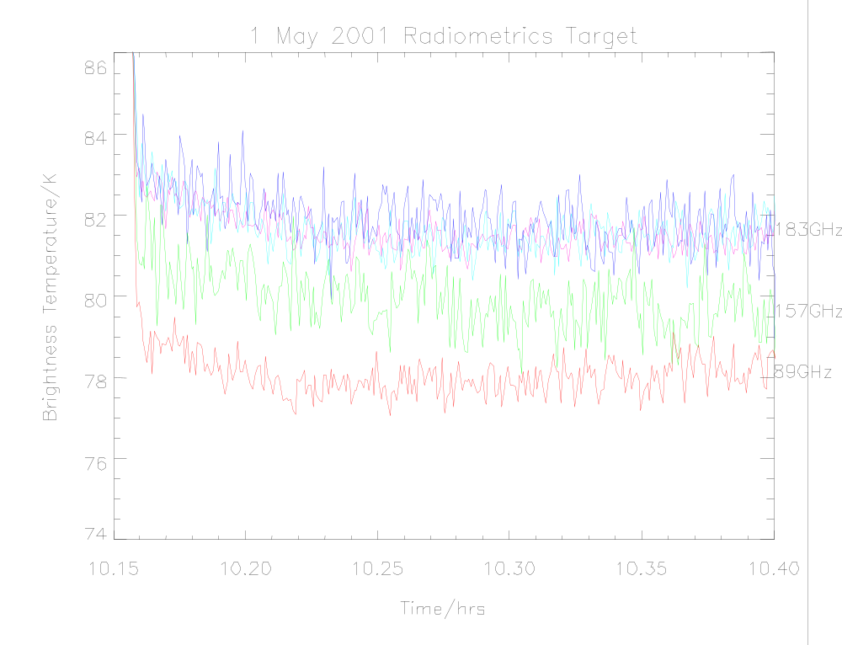
The measured brightness temperatures given in the final table of this report are based on the average brightness temperatures measured a period starting 10 minutes after filling.

Extinction by base of polystyrene target

Let's assume we can scale both the dielectric constant (wrt air ε = 1) and the loss tangent, tan δ with the density of polystyrene foam.

The nominal density of solid polystyrene (from Kaye & Laby) is d₀ = 1050 kg m⁻³
The measured density of the foam used in Radiometrics target is d = 23.6 kg m⁻³
So this represents only about 2.2% of the density of the solid material.
According to Sanford [1995], the dielectric constant of the foam can be assumed to be:
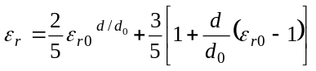
Lamb [1996] reports a number of measurements of polystyrene loss tangents, tan δ, at millimetre wavelengths, which show consistent frequency dependence of the form:
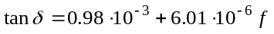
where f is the frequency in GHz.

We assume that the imaginary part of the dielectric constant scales linearly with foam density.

From these figures, the power attenuation coefficient can be calculated as:
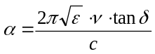

This theory has been tested by inserting additional slabs of polystyrene (at ambient temperature) between the radiometer and a cold scene. The actual absorption/emission from the base of the target will be less than these figures, it average temperature will be between that of LN2 and ambient.

Then, the emission from the addition of a dx = 5 cm slab of ambient polystyrene foam placed in the path of a liquid nitrogen target can be estimated, as ΔT_{LN2} = [(10 ^{α'dx /10})-1] * (297K - 77K).

Reflections from the polystyrene-air interfaces are negligible, based on their similar dielectric constants.

The only remaining explanation is scattering by the polystyrene beads themselves. These are observed to be approximately 2mm diameter, which is of the order of a wavelength at MARSS frequencies. This is the regime in which volume scattering is most efficient. Anthony Baran has modelled the scattering cross section of polystyrene beads of 1, 2 and 3 mm diameters with the above dielectric characteristics. His figures showed the single scattering albedo was less than 1 for all frequencies considered. As this is defined as the ratio of the scattering coefficient to the total extinction coefficient, it can be concluded that scattering is not the dominant process. Thus it must be concluded that the assumed dielectric constant must be in error.

Reflections from the LN2-polystyrene interface

Vinogradov measured the refractive index of liquid nitrogen, 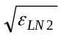= 1.196 at 2.3mm. This results in a power reflectivity of the LN2-polystyrene interface to be 0.0066. For a planar interface between liquid nitrogen at ~80K and an ambient scene of ~290K viewed normally, this amounts to a contribution of 1.4K. Clearly there a large uncertainty in this term, which dominates the error budget of the calibration target at low frequencies as used by Radiometrics. It is expected to be constant with frequency.

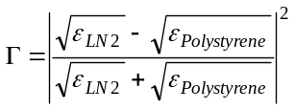

It has been argued that in reality, the LN2-polystyrene interface does not form a planar surface due to the permeability of the polystyrene to LN2, which acts to dampen the surface reflections. However, this is difficult to quantify, so the above figure should be taken as an approximate upper limit. The initial decrease in brightness temperatures observed

The accuracy of this term is limited by our knowledge of the dielectric properties, as well as the accuracy of the approximation of planar geometry and smooth surfaces. These effects limit the accuracy to ±20% ie ±0.3K.

Oxygen condensation from the atmosphere

Theoretically, there is a possibility of oxygen condensing from the atmosphere into the liquid nitrogen, as its boiling point is slightly higher than that of nitrogen. This would produce a eutectic mixture, with an elevated boiling point. As the calibration target enclosure is rapidly filled with dry nitrogen gas in operation, this will purge any oxygen from the air and form a cold pool, preventing further oxygen entering the target. The maximum amount of oxygen available to condense into the nitrogen is estimated to be 6 g. This represents less than 0.1% of the volume of the nitrogen and can safely be ignored.

Modelling the Loss introduced by the base of the Polystyrene Target

The processes described above were evaluated in a spreadsheet to assess how accurately the brightness temperature of the target could be modelled. This is shown below.

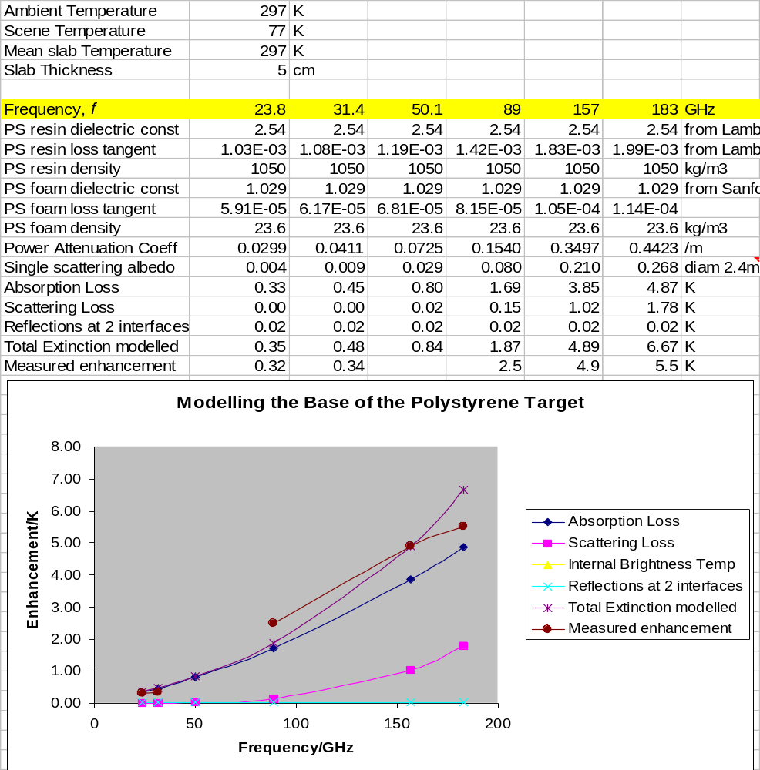

In this case, good agreement is found between the modelled enhancement in brightness temperatures and those measured by inserting an extra slab at ambient temperature between the radiometer and the reference scene. However, these calculations assume the polystyrene to be at ambient temperatures. It has already been mentioned that the brightness temperatures are observed to decrease during the first few minutes after the target is filled with cryogen. If this is due to the cooling of the polystyrene, a lower figure should be used for its temperature, which results an underestimation of the enhancement by a factor of 2.

Absolute Brightness Temperature of Radiometrics Target in zenith view

The magnitude of each of the above terms is summarised in the following table, together with estimates of the uncertainty of the dominate terms. The measured insertion losses are used here, scaled to correspond to the average temperature of the polystyrene being 186K.

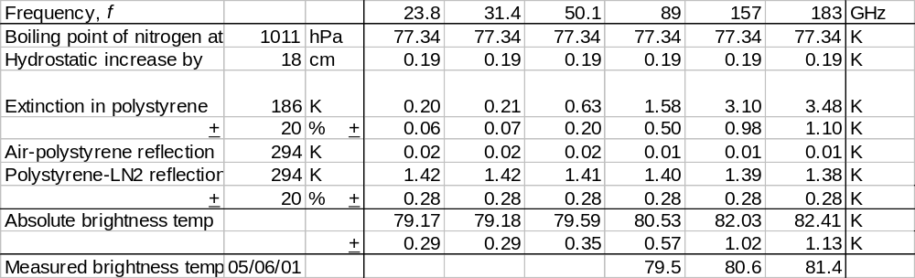

It can be seen that the target provides an accurate reference at low frequencies, but the uncertainties grow rapidly with increasing frequency.

Observed brightness temperatures immediately after the target is initially filled with LN2, and subsequent observations in steady state, suggest that the reflections in the polystyrene-LN2 interface may be over-estimated. If this term is omitted, good agreement is found between the theoretical and observed brightness temperatures of the target.

Absolute Brightness Temperature of Met Office Target in nadir view

In this case, the only corrections that need to be applied to the boiling point of nitrogen are due to reflections in the interface between air and LN2. Here, this is assumed to be a planar interface. However, this may not be the case in practice, due to the vigorous boiling disturbing the surface. After an initial settling period, such disturbances are seen to diminish.

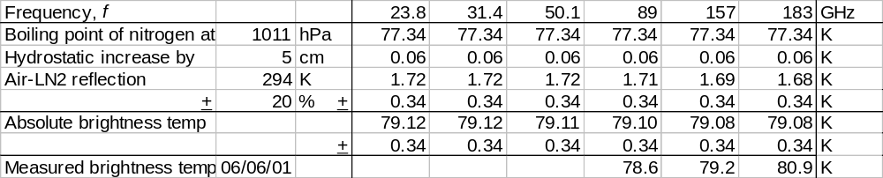

It can be seen that the target provides an accurate reference at 89 and 157 GHz, but observations at 183GHz show a small bias. The cause of this is unknown.

Recommendations

- The Radiometrics target provides an excellent reference for relative measurements and laboratory investigations, due to its radiometric stability over long periods (>30 minutes), provided its surfaces remain free of condensation (dewpoint <+8°C). This could be ensured by placing the target is a sealed container, such as a bag of "balloon material" (low density polyethylene, 8 μm thick) purged with dry nitrogen.

- The first 10 minutes of data after filling the target should be discarded to avoid the observed initial cool-down response.

- Establish whether the polystyrene does become permeable to liquid nitrogen, and whether the term representing the increase in brightness temperatures due to reflections in this interface is valid.

- Once the interface reflection term has been established, the extinction due to the polystyrene base needs to be evaluated accurately. This may be best done viewing down into an open target of liquid nitrogen. Although the absolute brightness temperatures will be uncertain, this will provide a stable, contrasting background against which to evaluate the loss introduced by the insertion of a suitable slab of polystyrene foam between the radiometer and the target, without introducing possible condensation in the path.

References

James W. Lamb,
"Miscellaneous Data On Materials For Millimetre And Submillimetre Optics,"
Int. J. IR and Millimeter Waves, vol. 17, no. 12, pp. 1997-2034, Dec. 1996
Available from http://www.ovro.caltech.edu/~lamb/ALMA/Receivers/mmMaterialProperties2.pdf

J.Sanford,
"A Luneberg lens update," IEEE Antennas and Propagat. Vol.37, No.1, pp.76-69, Feb 1995.

E.A.Vinogradov, E.M.Dianov and N.A.Irisova,
"Dielectric characteristics of liquid nitrogen at lambda=2.3mm,"
Soviet Physics - Technical Physics, Vol.11, No.7, 1967, p.983.

